05th October 2017

**YOKOHAMA to Exhibit at 45th Tokyo Motor Show 2017**

YOKOHAMA will participate in the 45th Tokyo Motor Show 2017, to be held at Tokyo Big Sight from 25th October through 5th November (open to the general public from 28th October). Commemorating the 100th anniversary of its founding this October, YOKOHAMA will use this year’s Tokyo Motor Show to showcase its long history of tyre products that have provided drivers with exciting performance. The YOKOHAMA booth also will feature some of the Company’s currently popular tyre models and highlight YOKOHAMA’s technological prowess with informative displays about its rubber technologies and next-generation technologies that will shape the future of automotive tyres.

The booth will feature a number of tyres that have excited the senses of car aficionados over the years, including a reproduction of Japan’s first corded tyre, the “Hama Town Cord” (produced in 1921); YOKOHAMA’s first radial tyre, the “G.T. SPECIAL” (introduced in 1967), and the “ADVAN HF” (introduced in 1978), the launch of which marked the beginning of a new tyre category, the sport radial tyre. The “ADVAN HF Type D”, launched this autumn, and the “ADVAN 052”, a street sport tyre that delivers superior driving performance will bring the historical display right up to the present. These tyres illustrate the spirit of challenge that has driven the YOKOHAMA brand for 100 years and constantly led to the development of the most advanced, high-performance tyres.

The booth’s display on rubber technologies will focus in particular on wet grip technology. The booth will display a number of YOKOHAMA tyres that offer superior wet grip performance, including the “ADVAN dB V552”, which will be introduced to markets sequentially from this November as a premium comfort tyre and the most silent-running tyre ever developed by the Company; the “ADVAN Sport V105”, YOKOHAMA’s global flagship tyre that comes factory-equipped on many premier car models; and the high-performance, highly fuel-efficient “BluEarth-A”. The YOKOHAMA brand now includes the industry’s first 200-plus tyre sizes* to be awarded the ultimate “a” ranking for wet grip performance in Japan’s tyre labeling system.

* 212 sizes (as of 30th September 2017)

The booth will also display two new tyres featuring next-generation technologies. The first is a lightweight tyre designed to be more eco-friendly by using less natural resources and being lighter than the conventional product. The second is an evolutionary aerodynamic tyre that delivers superior fuel efficiency and safety by controlling the flow of air to the vehicle. In addition, from 25th October to 29th October, visitors to the YOKOHAMA booth will be able to see the 2016-17 Premier League championship trophy won by the Chelsea Football Club, with which YOKOHAMA has a partnership.

YOKOHAMA plans to hold a press conference at the site from 10:00 a.m. on 26th October.

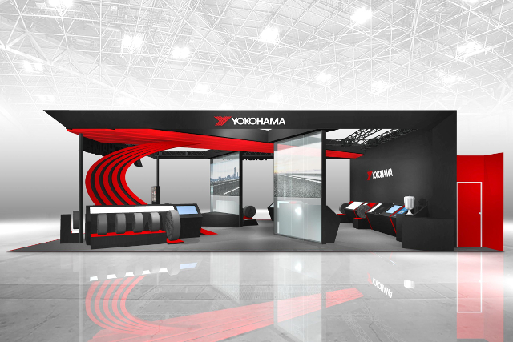

*Image of the YOKOHAMA booth at Tokyo Motor Show 2017*